Experiment 05: To implement a Bluetooth network

PART A

A.1 Aim: To implement a Bluetooth network with application as transfer of a file from one device to another.

A.2 Objectives: To understand the security algorithms in mobile networks

A.3 Outcome: Students will be able to articulate the knowledge of GSM, CDMA & Bluetooth technologies and demonstrate it.(LO-2)

A.4 Theory:
Bluetooth is a wireless technology standard used for exchanging data between fixed and mobile devices over short distances using UHF radio waves in the industrial, scientific and medical radio bands, from 2.402 GHz to 2.480 GHz, and building personal area networks (PANs). It was originally conceived as a wireless alternative to RS-232datacables.
Bluetooth is managed by the Bluetooth Special Interest Group (SIG), which has more than 35,000member companies in the areas of telecommunication, computing, networking, and consumer electronics. The IEEE standardized Bluetooth as IEEE802.15.1,but no longer maintains the standard. The Bluetooth SIG oversees development of the specification, manages the qualification program, and protects the trademarks. A manufacturer must meet Bluetooth SIG standards to market it as a Bluetooth device.

Transfer of words between two phones using Bluetooth is done below.

A.5Code: Main_Activity.java:https://github.cm/vinaynpp/mcc package com.example.bluetooth_communication;importandroid.app.Dialog;
importandroid.bluetooth.BluetoothA
dapter;importandroid.content.Intent; importandroid.content.pm.PackageMa nager;import
android.content.pm.ResolveInfo;impor tandroid.net.Uri; importandroid.os.Environment; import
androidx.appcompat.app.AppCompatActivity;i mportandroid.os.Bundle;
import
android.view.Menu;impor tandroid.view.MenuItem;i
mportandroid.view.View; import
android.widget.AdapterView;i
mportandroid.widget.ArrayAda pter;importandroid.widget.Butt on;import
android.widget.EditText;import android.widget.ListVie
importandroid.widget.TextView;i
mportandroid.widget.Toast;

importjava.io.File;import java.util.ArrayList;importj ava.util.List;

publicclassMainActivityextendsAppCompatActivity{
//CreateObjects ButtonbuttonopenDailog,buttonUp,send;Te xtViewtextFolder;
EditTextdataPath;
staticfinalintCUSTOM_DIALOG_ID=0;ListVie wdialog_ListView;
Fileroot,fileroot,curFolder;
privateList<String>fileList=newArrayList<String>();priva te static final int DISCOVER_DURATION =
300;privatestaticfinal intREQUEST_BLU =1;
BluetoothAdapterbtAdatper=BluetoothAdapter.getDefaultAdapter();
//@Overri de protected void onCreate(Bundle savedInstanceState)

{ super.onCreate(savedInstanceState);setContentView(R.layout.activity
_main);dataPath=(EditText)findViewById(R.id.FilePath);buttonopenDa ilog= (Button)
findViewById(R.id.opendailog);send=(Button)findViewById(R.id.sendB
tooth);buttonopenDailog.setOnClickListener(newView.OnClickListener
(){
@Override
public void onClick(View v)
{dataPath.setText("");showDialog(CUSTO M_DIALOG_ID);
}
});

root=newFile(Environment.getExternalStorageDirectory().getAbsolutePath());cur
Folder= root;
send.setOnClickListener(newView.OnClickListener(){@O verride
publicvoidonClick(Viewv){sen dViaBluetooth();
}
});
}
@Override
protectedDialogonCreateDialog(intid){Dia logdialog = null;
switch(id) { caseCUSTOM_DIALOG_ID:
dialog = new
Dialog(MainActivity.this);dialog.setContentView
(R.layout.dailoglayout);dialog.setTitle("File
Selector");dialog.setCancelable(true);dialog.set
CanceledOnTouchOutside(true); textFolder = (TextView)
dialog.findViewById(R.id.folder);buttonUp = (Button) dialog.findViewById(R.id.up);buttonUp.setOnClickListener(ne wView.OnClickListener(){
@Override
public void onClick(View v)
{ListDir(curFolder.getParentFile());
} });
dialog_ListView = (ListView)
dialog.findViewById(R.id.dialoglist);dialog_ListView.setOnItemClickListener(newAdapt erView.OnItemClickListener(){
@Override
publicvoidonItemClick(AdapterView<?>parent, Viewview,int
position,longid){Fileselected =newFile(fileList.get(position));
if(selected.isDirectory()){Li stDir(selected);
}elseif(selected.isFile()){get selectedFile(selected);
}else {
dismissDialog(CUSTOM_DIALOG_ID);
}
} });
break;
}
returndialog;
}

@Override
protectedvoidonPrepareDialog(intid,Dialogdialog){supe
r.onPrepareDialog(id,dialog);
switch(id) { caseCUSTOM_DIALOG_ID:
ListDir(curFolder); break;
}
}

public void getselectedFile(File
f){dataPath.setText(f.getAbsolutePath());fileLi
st.clear();dismissDialog(CUSTOM_DIALOG_ID);
}

publicvoidListDir(Filef){if(f.
equals(root)){
buttonUp.setEnabled(false);
}else { buttonUp.setEnabled(true);
}
curFolder =
f;textFolder.setText(f.getAbsolutePath());
dataPath.setText(f.getAbsolutePath());Fi le[]files=f.listFiles();fileList.clear();

for (File file : files)
{fileList.add(file.getPath());
}
ArrayAdapter<String>directoryList=newArrayAdapter<String>(this,andr oid.R.layout.simple_list_item_1,fileList); dialog_ListView.setAdapter(directoryList);
}

//exittoapplication
public void exit(View V)
{btAdatper.disable();
Toast.makeText(this,"***NowBluetoothisoff...Thanks. ***",Toast.LENGTH_LONG).show();finish();}

//Method for send file via bluetoothpublicvoid

sendViaBluetooth(){
if(!dataPath.equals(null)){i f(btAdatper ==null) {
Toast.makeText(this,"Devicenotsupport bluetooth",Toast.LENGTH_LONG).show();
}else { enableBluetooth();
}
}else{
Toast.makeText(this,"Pleaseselectafile.",Toast.LENGTH_LONG).show();
}
}

publicvoidenableBluetooth(){In tentdiscoveryIntent=new
Intent(BluetoothAdapter.ACTION_REQUEST_DISCOVERABLE);discoveryIntent.putExtra(BluetoothAdapt er.EXTRA_DISCOVERABLE_DURATION,
DISCOVER_DURATION);
startActivityForResult(discoveryIntent,REQUEST_BLU);
}

//Overridemethodforsendingdataviabluetoothavailability--------------------------
@Override
protectedvoidonActivityResult(intrequestCode,intresultCode,Intentdata){ if (resultCode == DISCOVER_DURATION && requestCode == REQUEST_BLU) {Intenti
=newIntent();
i. setAction(Intent.ACTION_SEND);i.s etType("*/*");
File file = new
File(dataPath.getText().toString());i.putExtra(Intent.EXTR
A_STREAM,Uri.fromFile(file));
PackageManager pm =
getPackageManager();List<ResolveInfo>list=pm.queryIn tentActivities(i,0);if(list.size()>0){
StringpackageName=null;Str ing className = null;booleanfound=false;
for(ResolveInfo info : list) { packageName=info.activityInfo.packageName;
if(packageName.equals("com.android.bluetooth")){cla ssName=info.activityInfo.name; found=true;b reak;
}
}
//CHECKBLUETOOTHavailableornot------------------------------------------------ if(!found){
Toast.makeText(this,"Bluetoothnotbeenfound",Toast.LENGTH_LONG).show();
}else {
i. setClassName(packageName,className);
startActivity(i);
}
}
}else {
Toast.makeText(this,"Bluetoothiscancelled",Toast.LENGTH_LONG).show();
}
}

@Override
publicbooleanonCreateOptionsMenu(Menumenu){
//Inflatethemenu; thisaddsitems totheactionbar ifitis present.getMenuInflater().inflate(R.menu.menu_main,menu); returntrue;
}

@Override
publicbooleanonOptionsItemSelected(MenuItemitem){
//Handleactionbar itemclickshere.Theactionbarwill
//automatically handleclicks ontheHome/Up button,solong
//asyouspecifyaparentactivityinAndroidManifest.xml.intid = item.getItemId();

//noinspectionSimplifiableIfStatementif(i d ==R.id.action_settings) {
Toast.makeText(this, "****************\nDeveloper: Santosh Kumar
Singh\nContact:superssingh@gmail.com\n****************",Toast.LENGTH_LONG).show(); returntrue;
}
returnsuper.onOptionsItemSelected(item);
}
}
Output:
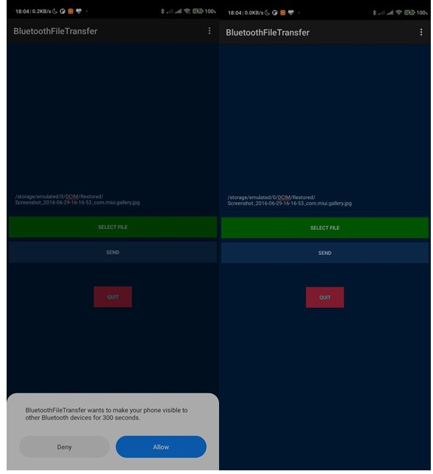
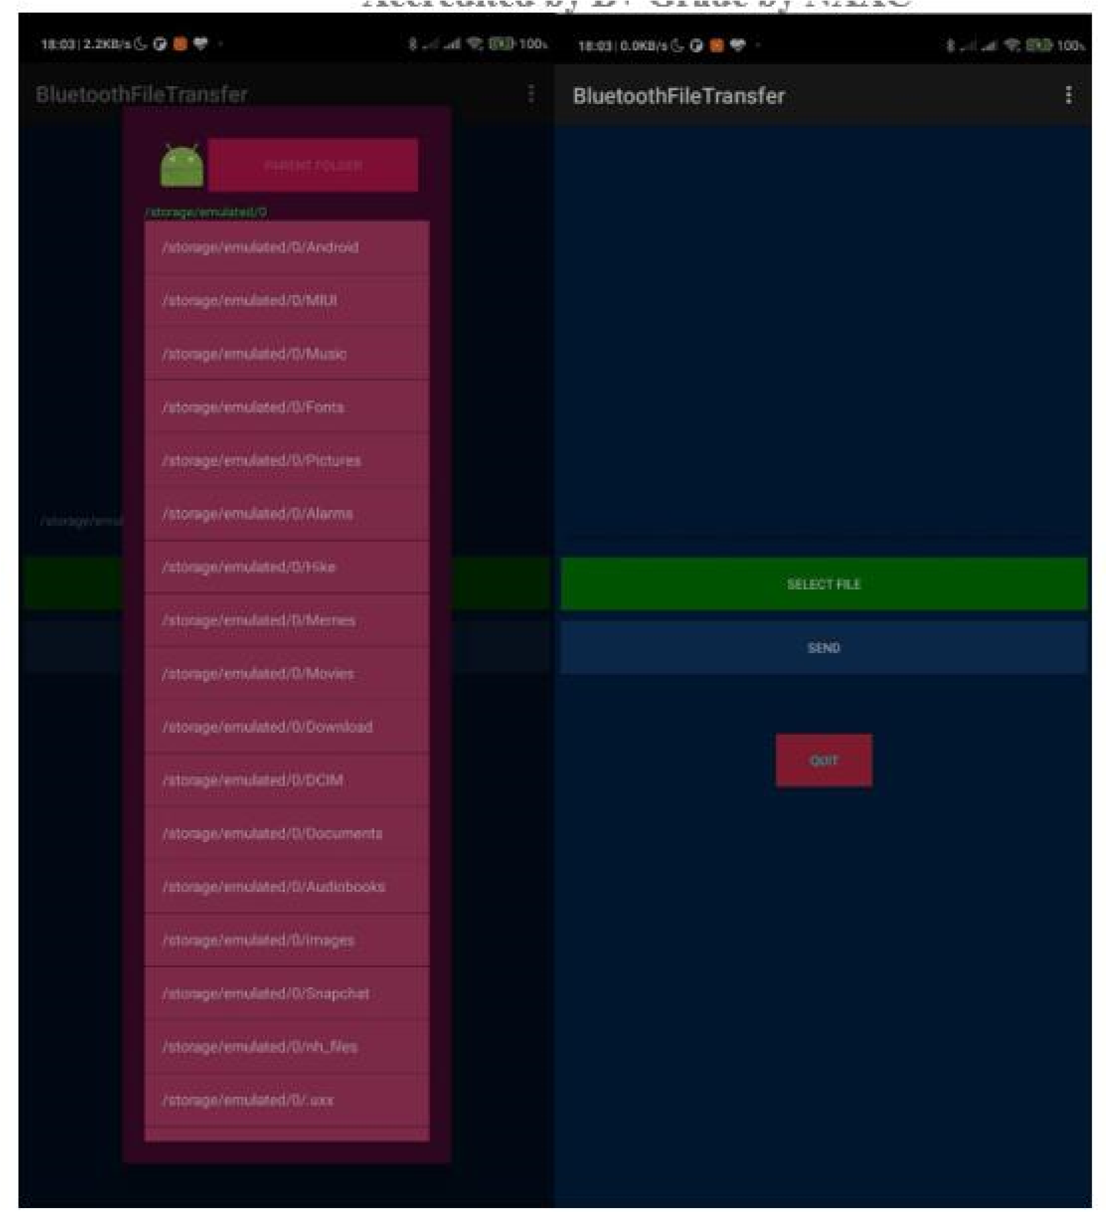

PART B

(PART B: TO BE COMPLETED BY STUDENTS)

(Students must submit the soft copy as per following segments within two hours of the practical. The soft copy must be uploaded on the Blackboard or emailed to the concerned lab in charge faculties at the end of the practical in case the there is no Black board access available)

Roll. No. C54 | Name: Quazi Md Moinuddin
Class: TE-C | Batch: C3
Date of Experiment: | Date of Submission: 25-02-25
Grade:

B.1 Software Code written by student/steps:
(Paste your Code script related to your case study completed during the 2 hours of practical in the lab here)
import android.app.Dialog; import android.bluetooth.BluetoothAdapter; import android.content.Intent; import android.content.pm.PackageManager; import android.content.pm.ResolveInfo; import android.net.Uri; import android.os.Environment; import androidx.appcompat.app.AppCompatActivity; import android.os.Bundle; import android.view.Menu; import android.view.MenuItem; import android.view.View; import android.widget.AdapterView; import android.widget.ArrayAdapter; import android.widget.Button; import android.widget.EditText; import android.widget.ListView; import android.widget.TextView; import android.widget.Toast;
import java.io.File; import java.util.ArrayList; import java.util.List;
public class MainActivity extends AppCompatActivity {
//Create Objects------------------------------------------------------- Button buttonopenDailog, buttonUp, send;
TextView textFolder;
EditText dataPath;
static final int CUSTOM_DIALOG_ID = 0;
ListView dialog_ListView; File root, fileroot, curFolder; private List<String> fileList = new ArrayList<String>(); private static final int DISCOVER_DURATION = 300; private static final int REQUEST_BLU = 1;
BluetoothAdapter btAdatper = BluetoothAdapter.getDefaultAdapter();
//---------------------------------------------------------------
@Override
protected void onCreate(Bundle savedInstanceState) { super.onCreate(savedInstanceState); setContentView(R.layout.activity_main); dataPath=(EditText)findViewById(R.id.FilePath); buttonopenDailog= (Button) findViewById(R.id.opendailog); send=(Button)findViewById(R.id.sendBtooth); buttonopenDailog.setOnClickListener(new View.OnClickListener() {
@Override public void onClick(View v) {
dataPath.setText("");
showDialog(CUSTOM_DIALOG_ID);
}
});

root = new File(Environment.getExternalStorageDirectory().getAbsolutePath()); curFolder = root; send.setOnClickListener(new View.OnClickListener() {
@Override public void onClick(View v) {
sendViaBluetooth();
}
});
}

@Override
protected Dialog onCreateDialog(int id) {
Dialog dialog = null; switch (id) { case CUSTOM_DIALOG_ID:
dialog = new Dialog(MainActivity.this); dialog.setContentView(R.layout.dailoglayout);
dialog.setTitle("File Selector"); dialog.setCancelable(true);
dialog.setCanceledOnTouchOutside(true);
textFolder = (TextView) dialog.findViewById(R.id.folder); buttonUp = (Button) dialog.findViewById(R.id.up);
buttonUp.setOnClickListener(new View.OnClickListener() {
@Override
public void onClick(View v) { ListDir(curFolder.getParentFile()); }
});
dialog_ListView = (ListView) dialog.findViewById(R.id.dialoglist); dialog_ListView.setOnItemClickListener(new AdapterView.OnItemClickListener() {
@Override
public void onItemClick(AdapterView<?> parent, View view, int position, long id) {
File selected = new File(fileList.get(position));
if (selected.isDirectory()) { ListDir(selected); } else if (selected.isFile()) {
getselectedFile(selected);
} else {
dismissDialog(CUSTOM_DIALOG_ID);
}
} }); break;
}
return dialog;
}

@Override
protected void onPrepareDialog(int id, Dialog dialog) { super.onPrepareDialog(id, dialog);
switch (id) { case CUSTOM_DIALOG_ID:
ListDir(curFolder);
break;
}
}

public void getselectedFile(File f){
dataPath.setText(f.getAbsolutePath()); fileList.clear();
dismissDialog(CUSTOM_DIALOG_ID);
}

public void ListDir(File f) { if (f.equals(root)) {
buttonUp.setEnabled(false);
} else {
buttonUp.setEnabled(true);
}
curFolder = f;
textFolder.setText(f.getAbsolutePath());
dataPath.setText(f.getAbsolutePath());
File[] files = f.listFiles(); fileList.clear();

for (File file : files) {
fileList.add(file.getPath());
}
ArrayAdapter<String> directoryList = new ArrayAdapter<String>(this, android.R.layout.simple_list_item_1, fileList);
dialog_ListView.setAdapter(directoryList);
}

//exit to application--------------------------------------------------------------------------- public void exit(View V) { btAdatper.disable();
Toast.makeText(this,"*** Now Bluetooth is off... Thanks. ***",Toast.LENGTH_LONG).show(); finish(); }

//Method for send file via bluetooth------------------------------------------------------------ public void sendViaBluetooth() { if(!dataPath.equals(null)){ if (btAdatper == null) {
Toast.makeText(this, "Device not support bluetooth", Toast.LENGTH_LONG).show();
} else {
enableBluetooth();
}
}else{
Toast.makeText(this,"Please select a file.",Toast.LENGTH_LONG).show();
}
}

public void enableBluetooth() {
Intent discoveryIntent = new Intent(BluetoothAdapter.ACTION_REQUEST_DISCOVERABLE); discoveryIntent.putExtra(BluetoothAdapter.EXTRA_DISCOVERABLE_DURATION, DISCOVER_DURATION);
startActivityForResult(discoveryIntent, REQUEST_BLU);
}

//Override method for sending data via bluetooth availability--------------------------
@Override protected void onActivityResult(int requestCode, int resultCode, Intent data) {
if (resultCode == DISCOVER_DURATION && requestCode == REQUEST_BLU) {
Intent i = new Intent();
i.setAction(Intent.ACTION_SEND);
i.setType("*/*");
File file = new File(dataPath.getText().toString());

i.putExtra(Intent.EXTRA_STREAM, Uri.fromFile(file));

PackageManager pm = getPackageManager();
List<ResolveInfo> list = pm.queryIntentActivities(i, 0); if (list.size() > 0) {
String packageName = null;
String className = null;
boolean found = false;

for (ResolveInfo info : list) {
packageName = info.activityInfo.packageName; if (packageName.equals("com.android.bluetooth")) {
className = info.activityInfo.name;
found = true; break;
}
}
//CHECK BLUETOOTH available or not------------------------------------------------ if (!found) {
Toast.makeText(this, "Bluetooth not been found", Toast.LENGTH_LONG).show();
} else {
i.setClassName(packageName, className); startActivity(i);
}
}
} else {
Toast.makeText(this, "Bluetooth is cancelled", Toast.LENGTH_LONG).show();
}
}

@Override public boolean onCreateOptionsMenu(Menu menu) {
// Inflate the menu; this adds items to the action bar if it is present.
getMenuInflater().inflate(R.menu.menu_main, menu); return true;
}

@Override public boolean onOptionsItemSelected(MenuItem item) {
// Handle action bar item clicks here. The action bar will
// automatically handle clicks on the Home/Up button, so long // as you specify a parent activity in AndroidManifest.xml.
int id = item.getItemId();

//noinspection SimplifiableIfStatement
if (id == R.id.action_settings) {
Toast.makeText(this, "****************\nDeveloper: Santosh Kumar Singh\nContact:
superssingh@gmail.com\n****************", Toast.LENGTH_LONG).show(); return true;
}
return super.onOptionsItemSelected(item);
}
}

B.2 Input and Output:
(Paste your output that you are getting after running app in from of screenshots.)
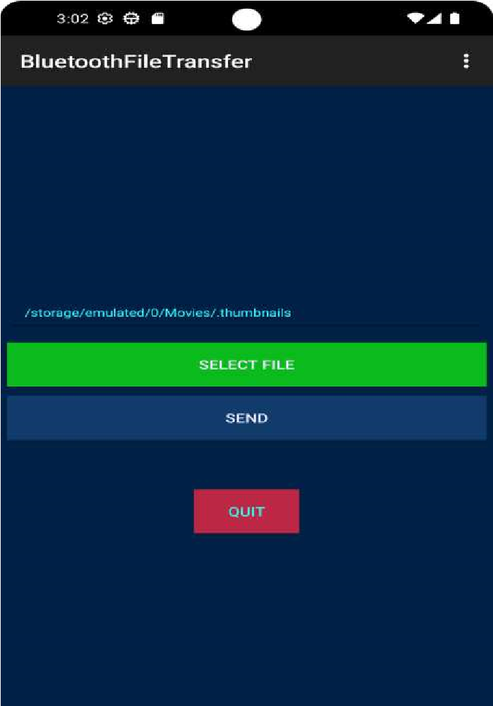
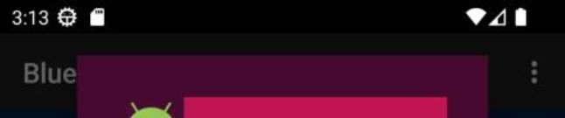
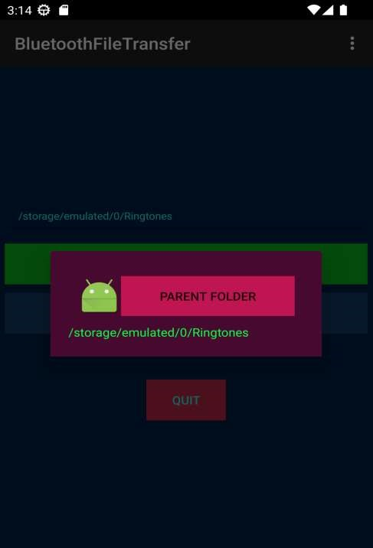
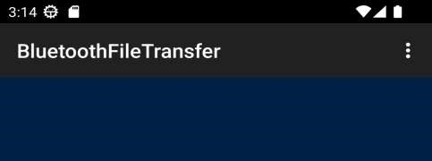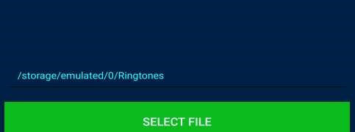
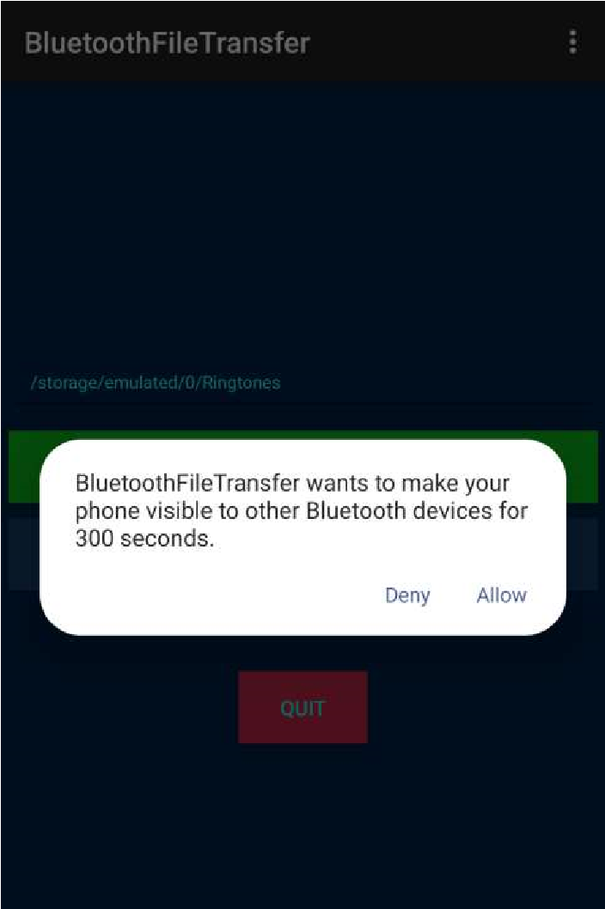

B.3 Observations and learning:
(Students are expected to comment on the output obtained with clear observations and learning for each task/ sub part assigned)
During the experiment, we successfully implemented a Bluetooth file transfer application, gaining practical insights into Bluetooth technology and its working principles. We learned about piconet, scatternet, and the process of pairing devices for secure data transmission.

B.4 Conclusion:
(Students must write the conclusion as per the attainment of individual outcome listed above and learning/observation noted in section B.3)
Through this hands-on experience, we deepened our understanding of mobile network security algorithms and Bluetooth protocols. The experiment provided valuable skills in Android development, particularly in coding for Bluetooth functionalities, contributing to our proficiency in mobile application development.

B.5 Question of Curiosity
(To be answered by student based on the practical performed and learning/observations)

Questions

- Explain Bluetooth architecture?
Ans :
Bluetooth Device: Any device that supports Bluetooth functionality, such as smartphones, laptops, headphones, speakers, etc.
Bluetooth Radio: This is the physical hardware component responsible for transmitting and receiving Bluetooth signals. It operates in the 2.4 GHz ISM band.
Bluetooth Stack: The Bluetooth protocol stack consists of multiple layers, including the Physical Layer, Link Layer, L2CAP (Logical Link Control and Adaptation Protocol), RFCOMM (Radio Frequency Communication), and higher-level protocols such as SDP (Service Discovery Protocol) and profiles like HFP (Hands-Free Profile) and A2DP (Advanced Audio Distribution Profile).
Bluetooth Profiles: Profiles define how Bluetooth devices communicate with each other and which features and functionalities they support. Examples include the Hands-Free Profile (HFP) for handsfree calling in cars and the Advanced Audio Distribution Profile (A2DP) for streaming high-quality audio.
Bluetooth Pairing: The process of establishing a secure connection between two Bluetooth devices by exchanging encryption keys. Pairing ensures that only authorized devices can communicate with each other.
Bluetooth Connection: Once paired, Bluetooth devices can establish a connection and exchange data wirelessly. Connections can be point-to-point or multipoint.

- What is piconet and scatternet?
Piconet:
A piconet is a network formed by one master device and up to seven slave devices. The master device coordinates communication within the piconet and controls the timing of data transmission. Slave devices synchronize their clocks with the master and can only transmit data when granted permission by the master.
In a piconet, the master device initiates communication with slave devices and manages the network. Slave devices can only communicate with the master, not directly with each other.
Bluetooth devices can participate in multiple piconets simultaneously, allowing for more complex network configurations.

Scatternet:
A scatternet is a network formed by connecting multiple piconets together. In a scatternet, devices may act as both master and slave in different piconets, allowing them to relay data between different networks.
Scatternets enable more extensive Bluetooth networks with greater flexibility and scalability. They allow devices to communicate with each other even if they are not within direct range, by relaying data through intermediate devices.
Devices in a scatternet may need to manage multiple connections and switch between different roles (master or slave) depending on the network topology and communication requirements.

